Pronith Laboratory

1. **Introduction**

[The introduction about Pronith Laboratory would be placed here]

1. **Project Requirement**
   1. **Doctor Manager** : to store the information of all doctor that brink the test to the labor
      * Administrator can Add/Edit/Delete all the information of doctor such as
        + First Name, Last Name, Sex, Phone, Email, Position, Working
      * Doctor can come with reference of another doctor (additional)
   2. **Patient Manager**: to store the information of all customer that test their blood
      * Administrator can Ad/Edit/Delete all the information of customer such as:
        + First Name, Last Name, Sex, National Identity Card, Phone
      * Patient can come with reference of doctor or can not
   3. **Ill Manager**: to manage all the illness to test. It divides to the group below:
      * **Ill Group**: it would has the title of **Ill Group**
      * **Ill**: it would has the title of **Ill**. It has been placed in difference **Ill Group**
      * **Ill Item Test**: it has been placed in difference **Ill** to store the result of the test. Example:

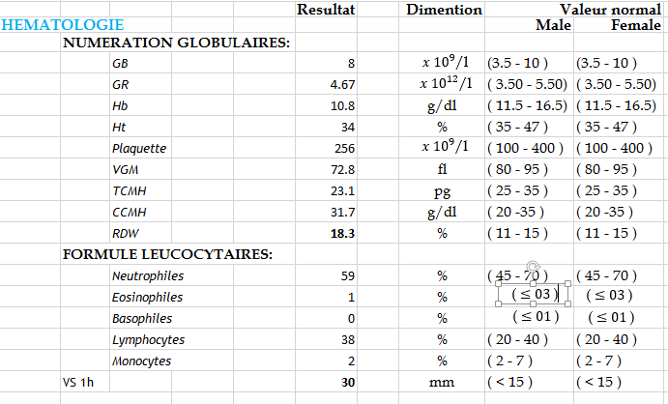

* 1. **Doctor Commission**: to manage the doctor commission when patient come to test their ill with reference of their doctor
     + When patient come to test the ill that has reference by the doctor, that doctor will get the commission that calculated by percentage (%) of total payment of patient test.
     + The percentage must be input by manual when admin create the patient ill test
     + When doctor got the commission, they can come to get from the laboratory administrator.
  2. **Patient Test Manager**: this is the important process of this system
     + Patient test manager coming with following step:
       - Patient come to laboratory for test (also doctor can bring the ill to test as well)
       - Administrator open the system and check the patient already registered or not yet (use to test at this laboratory).
         1. If not yet, administrator must register him before continue and check has reference of doctor or not.
         2. If already, find him by name, or phone, and select. Then continue.
         3. Note that if has reference of doctor, must include to display
       - Administrator get the ill (ex: blood), and select the ill type for test
       - After that he product the payment and print invoice for him
         1. Patient must pay for this testing or book pay
         2. The invoice must include the date come to take the result (date and time)
         3. Administrator send the ill (ex: blood) to the technical doctor to the laboratory system
       - After administrator receive the result from technical doctor, he open the system to input the result on the ill test that just registered
       - After input the result, administrator insure the result paper and print out wait for patient come to take it
       - When patient come to take it, he must show his invoice and administrator go to check in the system and check if payment already completed (already paid), he can give the result printed paper to patient, if not, he need to pay first before get the result paper.
  3. **Report Manager**: use for display the report of each module below
     + Report on ill test manager
       - Administrator can generate the report by filtering the data such as by date, patient, doctor, issue result, issue receive, and ill
       - Administrator can print it out and export in to excel file
     + Report on patient manager
       - Administrator can generate the report by filtering the data such as by date and doctor
       - Administrator can print it out and export into excel file
     + Report on doctor manager
       - Administrator can generate the report by filtering the data such as by date, or doctor reference
       - Administrator can print it out and export into excel file
     + Report on finance manager
       - Administrator can generate the report by filtering the data such as by date
       - Administrator can print it out and export into excel file
     + Report on doctor payment
       - Administrator can generate the report by filtering the data such as by date, doctor, issue paying
  4. **User**: is the user role that working in this system. There are two difference user role in this system
     + **Super-Administrator**
       - **Super-Administrator** can manage other **Super-Administrator**
       - **Super-Administrator** can manage all **Administrator**
       - **Super-Administrator** can do all the task that **Administrator** can do
     + **Administrator**
       - **Administrator** can do anything except manage **Administrator**

[update version 1]